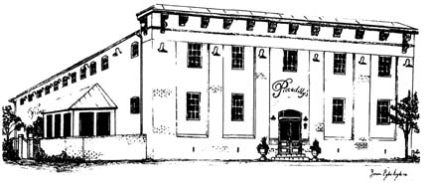
Piccadilly’s
Public House & Restaurant
Tour Group – Plated Dinner Menu
Menu Options - $32.00 Per Person (Includes Tax and Gratuity)
**Please Choose Three Entrees**
We Must Have a Final Count of Each Entrée 24 Hours in Advance
All Entrees Served with a Side Salad
Garlic Mashed Potatoes, & Vegetable Medley
Coffee, Tea, or Soda & Chef’s Choice Dessert

NEW YORK STRIP
Hand Cut & Grilled to Perfection

APPLE-THYME CHICKEN
Apple Brined and Finished
with a Sweet Herb Glaze

BEER BATTERED HADDOCK
Yuengling Battered White Fish Filet

GARLIC & BROWN SUGAR SALMON
Seared and Finished in a Sweet and Savory Glaze

PULLED PORK PLATTER
Hand Pulled Pork Topped with Barbeque Sauce

VEGETARIAN or VEGAN OPTION
Chef’s Choice

125 East Piccadilly Street Winchester, Virginia 22601
Reservations: 540-535-1899 ext. 182
Marshal Middleton
Special Events Manager
managers@piccadillysbrewpub.net
www.piccadillypublichouse.com

