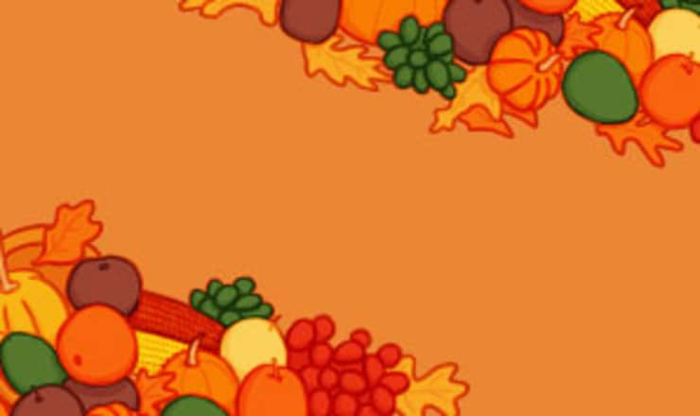
Piccadilly’s
Thanksgiving
Dinner
Noon – 5:00pm
Includes Three Courses
And soft drinks
$24.95
Garden or Caesar Salad

Roasted Turkey or Glazed Ham
(Gravy & Cranberry Sauce on the Side)
Sides - Pick Three:
Mashed Potatoes
Mashed Sweet Potatoes
Dressing/Stuffing
Corn Pudding
Green Bean Casserole
(Extra Meat $5 – Extra Side $3 Each)
Pumpkin Pie, Pecan Pie
or Cheesecake
*Kids Plate $12.95 (Entrée, Two Sides & Dessert)
Piccadilly’s
Thanksgiving
Dinner
Noon – 5:00pm
Includes Three Courses
And soft drinks
$24.95
Garden or Caesar Salad

Roasted Turkey or Glazed Ham
(Gravy & Cranberry Sauce on the Side)
Sides - Pick Three:
Mashed Potatoes
Mashed Sweet Potatoes
Dressing/Stuffing
Corn Pudding
Green Bean Casserole
(Extra Meat $5 – Extra Side $3 Each)
Pumpkin Pie, Pecan Pie
or Cheesecake
*Kids Plate $12.95 (Entrée, Two Sides & Dessert)

